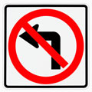

HELP FOR DRIVERS 80 AND OLDER
By Newcomb

This advice applies to all drivers, but is crucial for old, old people. Old drivers have several options unavailable to working people.

Retired people are not tied to time and the work place.
They do not commute.
They can live where they want.
They can choose the places they travel.
They can select the time of day to use the roadways.

Good choices put old drivers on the safest routes at slack times of day, aiding themselves and others. Old drivers can/should modify their driving with self- restricting, options:
Not driving in the dark
Turn off the radio, Telephone
Do not carry distracting passengers
Rarely backing up.
Seeking out intersections controlled by traffic signals.
As far as possible, use a green arrow for all left turns.
Become familiar with the local areas where you shop or visit.
Modify your route to include protected intersections. It is important to avoid intersections where stop signs control only one street.
Find and use the safety of a left turn Pocket.

Old drivers have the time to circle a block to reach a safe crossing, or when stuck at an unprotected intersection, to out-wait the traffic for a safer crossing.

If one feels insecure or anxious using a certain route, DON’T use it! Change where you shop or Doctor. Use the paid parking when available. It is money well spent. One doesn’t save money by seeking street parking. One fender-bender experience can waste time and money that would buy parking for the rest of your life.
Drive as if the DMV examiner is riding with you. Make such driving a habit. Wear your glasses and seat belt. Check your fuel level, mirror and seat positions before starting the car. Place your feet on the pedals to feel where they are ready to go or stop.
Become familiar with any car you drive, try out the dash options, the wiper, lights, turn signals, fuel, horn and telltale lights. Know how to dim the headlights and to turn on the four-way flasher if needed.

Traffic Control has a life of its own
A given intersection usually begins as a wide-open, free-for-all cris-crossing. (We see this in rural areas awaiting development.) Housing density closes in and the roads become more heavily traveled. Stop signs are installed. Everyone stops at all intersections.
People grumble as more and more cars stop and go. Police officers begin to manually, control traffic. Eventually, traffic signals are installed. Later turn arrows are needed.
Each, of these improvements comes after the need has been validated by accident and sometimes death.
This means that drivers are using dangerous intersections, taking unprotected ventures and risks. Odds that are especially unfavorable to old, old drivers.
(One might navigate the crossing several times before causing a serious accident.) The driver that stopped at the stop sign will be the driver 100% at fault!
When he left the sanctuary of the stop sign, he became the driver with “no right of way! “

This becomes a chess game. The pieces are autos. The game moves fast. Each player’s turn is only seconds long! The stakes are high. No one really wins.
“Dear Old Driver, the point is this: It is possible to continue a useful driving experience as an older driver, visiting, shopping and safely using your car. It is not necessary to quit driving in order to avoid these disaster areas.

If you find an area that is equipped with protected intersections, left turn pockets, traffic light controlled crossings and protected left and right turns, move there. Or use this area for your shopping, recreation and worship activities. *

*NEVER, attempt a left turn, into traffic, from a stop sign through an unprotected intersection! (The Badly needed ) NO LEFT TURN sign may/will be posted too late for you. If you don’t see this sign,, Pretend that it is there!
. 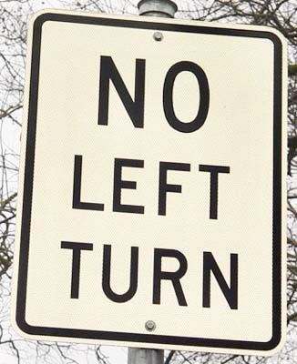
*(If one must break this rule), Remember that increased, safety is one’s reward for limiting an unsafe practice.

“FOUR EYES SEE MORE THAN TWO EYES SEE!”

If there is a person seated to the driver’s right: * This person can watch the traffic approaching from the right and advise the driver of the times that there is a safe vacant space for him to cross or turn. This allows the driver to watch the traffic to his left.
* This RIGHT watcher continues the changing vocal traffic update “three cars, one car, no car now.” “ After this car” “not now” etc. (The driver adds this vocal information to his left vision and can process a safer use of the intersection.)
The driver waits for his turn to move. There will be times when traffic from both directions is so spaced that he can safely move through the temporally, empty intersection.

Normal traffic pattern is for cars to move in pulses that create small clumps of cars, in both directions. There will be four space conditions of interest to the driver.
None, where the intersection is full, left and right.
Left, where the intersection is free from the left.
Right where the intersection is free from the right.
VACANT where the intersection is totally available!

Waiting for this Perfect moment may take longer than one waits for traffic lights This is the only ‘TURN’ that one has at the unprotected intersection. A right turn is still the safest movement the driver can make, followed by crossing, and last, the dreaded turn to the left.
2008, soon, cars are to be made available with added side cameras to help all drivers.

* The second pair of eyes can also assist the driver when changing lanes. These two eyes can scan the BLIND Spot for cars hidden at the right rear nw

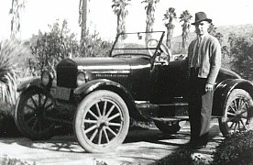
1927 T Ford 2 Door Roadster

