THE WORLD’S LARGEST
“RADIO” STATION
by CARLOS A. ALTGELT

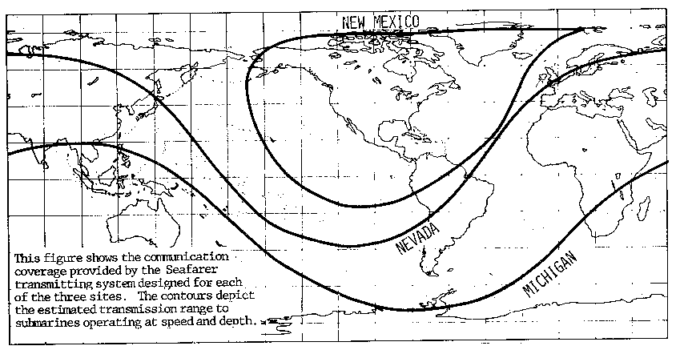

FIRST MADE PUBLIC by the US Navy in 1968 as Project Sanguine ⁽¹⁾, the Extremely Low Frequency communications project—Project ELF—is designed to communicate with deeply-submerged submarines. Project ELF uses low-frequency waves to signal one-way coded messages to US and British Trident and Fast Attack submarines. The system alerts them to surface to receive a more detailed communication.

Mammoth Projects...

Project Sanguine would have made use of some two-fifths of Wisconsin in the construction of a giant ELF transmitter capable of being heard all over the world. A committee set up to investigate possible biological effects vetoed the concept. A new variant, Project Seafarer, was next proposed. Again, the system was halted. Finally, Project ELF was approved and can now broadcast at frequencies between 30 Hz to 300 Hz.

Project ELF, which became operational in 1989, consists of two transmitters, one near Clam Lake in Northern Wisconsin, and the other at Republic, in Michigan’s Upper Peninsula. (Actually, Michigan’s antenna intersection is located east of Republic, while the transmitter site is in the Gwinn area nearby, with no settlements of any size between the two towns.)

The Michigan and Wisconsin sites, separated by 145 miles as the crow flies, must operate simultaneously to meet worldwide coverage requirements.

...with Huge Antennas

One of the great difficulties associated with the use of ELF for communication purposes, is the problem of generating a useful signal. The physical size of an antenna that can produce a useable signal with reasonable efficiency is inversely proportional to the frequency.

The Wisconsin antenna consists of two lines, each about 14 miles long. The Michigan antenna uses three lines, two about 14 miles long and one roughly 28 miles long.

Originally, the antennas were to be buried 6 feet underground, but reasons of economy dictated otherwise. The antennas that were actually built look like a power line, mounted on 40-foot wooden poles with a transmitter building near each antenna system. The transmitter facility in Michigan uses about six acres of land and the one in Wisconsin, deep in the Chequamegon National Forest, about two acres. A 165-mile underground cable connects the two sites which have a typical operating frequency of 76 Hz. Due to its low frequency, the antenna systems is huge: a directly-generated electromagnetic wave at 76 Hz has a wavelength of 2,452 miles.

The very first ELF transmission from Clam Lake (an old Navy facility built years before Michigan’s site) took place in May 1982, when a message was successfully received by a submarine submerged at a depth of 400 feet in the Atlantic Ocean off the Florida coast. According to Paul Brodeur (Currents of Death), that experiment so impressed a newspaper publisher that he promptly endorsed Project ELF.

Underwater Signals

As a result of the high electrical conductivity of sea water, signals are attenuated rapidly as they propagate downward through it. In effect, sea water "hides" the submarine from detection while simultaneously preventing it from communicating with the outside world through conventional high-frequency radio transmissions.
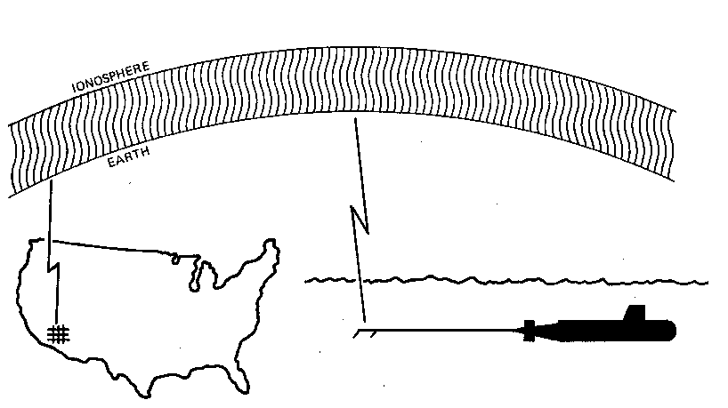

The submarine detects a Nevada-site ELF signal with a long trailing antenna that stretches for several hundred yards behind and above its deck.

In order to receive these, a submarine must travel at slow speed and be near the surface.

Unfortunately, both of these situations make a submarine more susceptible to enemy detection. Lower frequencies, such as those in the ELF range, however, can be received considerably deeper in the ocean.

Project ELF’s signal of 76 Hz is capable of forming strong wavefronts and penetrate well below the ocean’s surface. (Very Low frequency (VLF) signals, those between 3 kHz to 30 kHz were used by the Navy before but they can barely penetrate the water’s surface—see sidebar above.)

Millions of watts are transformed into a 2,500-mile long wave that turns the Laurentian granite bedrock of Lake Superior into a massive antenna for deep sea contact with the submarine fleet. The efficiency of these transmitters is very poor, however, and a large amount of energy is wasted as heat.

A Greek…

Navy officials had become interested in ELF radiation back in 1958, when they learned that radio waves oscillating just above the 60 Hz range could penetrate seawater sufficiently to provide communication with deeply submerged submarines. Because the wavelength of such a signal is nearly 2,500 miles, it was feared at the time that ELF transmitting antennas would have to be unduly large. This problem was solved, however, by Nicholas Christofilos, a brilliant Greek-born physicist working for the Department of Defense, who suggested that a portion of the earth’s interior could be used as a launching pad to propagate ELF signals. During the early 1960s, Christofilos’s concept was successfully tested, and in 1969 the Navy and the RCA Corporation built an ELF test facility near Clam Lake, Wisconsin, by burying twenty-eight miles of insulated cable in the low-conductivity granite bedrock of the Chequamegon National Forest.
Soon thereafter, the Navy proposed to construct a 22,500-square-mile antenna system [by] burying 6,000 miles of cable in bedrock elsewhere in Northern Wisconsin and in the Upper Peninsula of Michigan. The idea was to form a giant grid so that electric current generated by transmitters would pass through the antenna cables and flow deep into the earth along the bedrock, creating a global ELF radio field [NB: it would certainly be an electromagnetic wave, but definitely not a “radio” wave!] extending up to the ionosphere [which] would reflect a portion of the ELF field into the world’s seas and oceans.

Paul Brodeur (Currents of Death)

Technical Data

An ELF message provides basic information. It’s really a backup of existing, higher-frequency, radio-based communication systems. But, while ELF signals do not provide the rate of information and speed of transmission of other systems, it “gets through” while the others cannot.

As we pointed out previously page, it is also a one-way, non-voice system, but it provides sufficient information to the submarine’s commander to surface to receive more information via other means.


Overhead Antennas
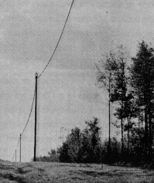

The ELF antennas, resembling an ordinary power distribution line, are located above ground in cleared right-of-ways that are 70-100 feet wide. The antennas consists of two conductors in Wisconsin and a single conductor in Michigan. The transmitter sends an electrical current through the antenna cables into the earth at the ground terminals. The end of each antenna element is terminated with one to three miles of buried horizontal ground wire and typically one or more arrays of well-type electrodes extending to depths of 100 to 300 feet. The current then flows back to the transmitter through the earth, completing the circuit. Most of the earth current flows deeply, and disperses through the non-conductive bedrock underlying the ELF system around and between the two sites.

(From IIT Research Institute reports.)

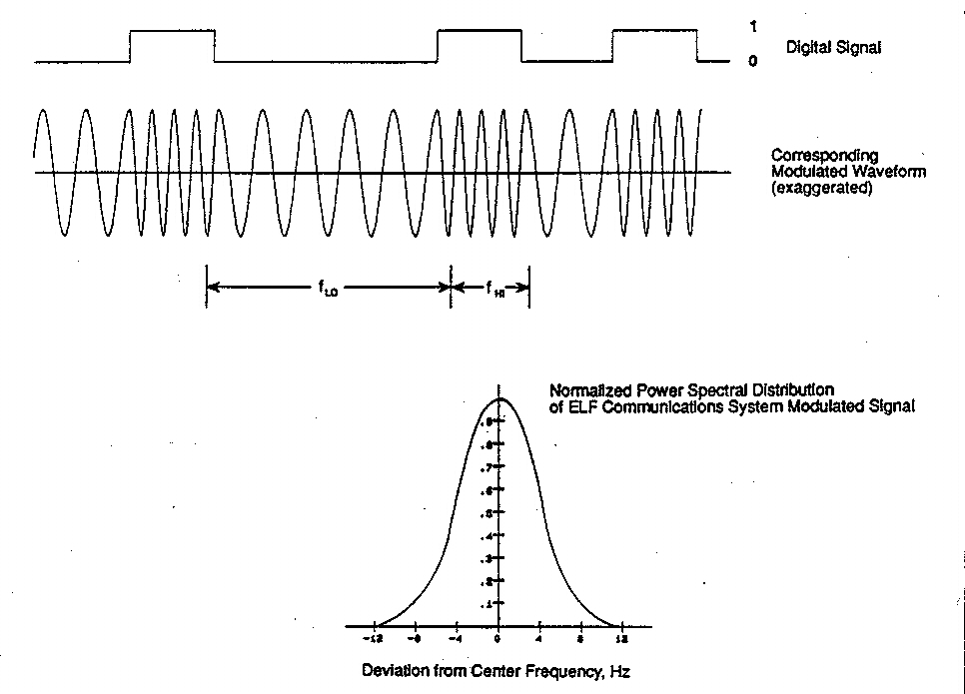

ELF MODULATED WAVEFORM AND POWER SPECTRAL DISTRIBUTION

The US Navy ELF Communications System uses a frequency modulation principle known as “minimum key-shifting” centered around 76 Hz. In this type of modulation, the signal consists of smoothly connected segments of sinusoids of two distinct frequencies. The figure shows a signal shifting between 72 Hz and 80 Hz depending on whether an analogous code of “one” or “zero” is being transmitted. Transitions from one frequency to the other occur at the peak of zero crossings of a wave in order to minimize the bandwidth of the frequency spectra. Both transmitters at Clam Lake and Republic can operate at other center and shift frequencies but have not done so operationally. These 76 HZ FM signals have field intensities much larger (and mask) ambient 60 Hz unmodulated field intensities generated by power utility transmission and distribution lines.

(From Technical Reports D06205-3 and D06214-6
by the IIT Research Institute, Chicago.)

Once on the surface, the commander will receive the detailed orders via more conventional VLF signals at 17 kHz and 26 kHz. Most of the communications are done by raising a mast out of the water and querying a submarine.

A problem with the signal is the inefficiency of the antenna system: it takes a long time to send a very short message via ELF. While a radio signal can carry vast amounts of information, ELF is very slow.

…and a German

ELF was accidentally detected in World War I when the Germans noticed a very low frequency noise in the ground which had a strong resonance at 7 Hz [The] Germans felt that the noise was caused by electrical storms. The phenomenon was dismissed as interesting but of no practical use. It was not until the early 1950s that interest in ELF began again. In 1952 a German scientist named W. O. Schuman pointed out the existence of a cavity between the earth and the ionosphere that has a fundamental resonant frequency of about 7 Hz. A radio wave having the same frequency [NB: one more time, it isn’t a “radio” field!] can be broadcast into this cavity [and] will travel 25,000 miles around the world at the speed of light. [Other] scientists quickly added to Schuman’s discoveries. They found out more about the resonances: frequencies below 100 Hz do not fade out. [These] discoveries set the stage for the ELF concept.

L. W. Klessig and V. L. Strite (The ELF Odyssey)

Based on parameters supplied by the Navy, estimates have ranged from 1 bit per second to 1 bit per 10,000 seconds. But the Navy feels that low data rates present no problems, since signals of just a few letters can convey quite a bit of pre-encoded information (no pun intended!). A Navy spokesman claimed that the Navy is “in a way . . . going back to the days of flag hoists . . . when we had the general signal books and ran whole fleets for whole wars on just two- and three-letter signals” (US Navy’s Seafarer Final Environmental Impact Statement, April 1972). But, in the same report, a congressman suggested that only a few characters could be sent every 15 minutes while others estimated that it will take almost two hours to send a coded message just twelve letters long.

Geological Requirements

An ELF antenna sends a signal from the ground to the ionosphere where it travels around the world filtering down through the ocean depths to reach the fleet of submarines (see figure above). Due to the limits of the lengths of the system’s antennas (less than 100 miles versus the required 2,500 miles to generate a 76 Hz electromagnetic wave), the antennas are placed near nonconductive rocks from the Precambrian era. To be useful, the rock formation must be fairly close to the surface and be large enough to support the ELF antenna grid. The rocks must be as nonconductive as possible so as not to “shorten” the electromagnetic wave.

Few places in the United States meet those conditions, Wisconsin and Michigan being the best two.

Power-A-Plenty

At the outset, Project Sanguine was to require 240 transmitters and a total power requirement of 800 megawatts with a current of 100 amps. The total land area needed was estimated at 20,000 square miles (about the size of Belgium and Holland combined). In the end, the power required for the Michigan and Wisconsin sites was reduced to less than 5 megawatts and eight acres for the transmitter sites.

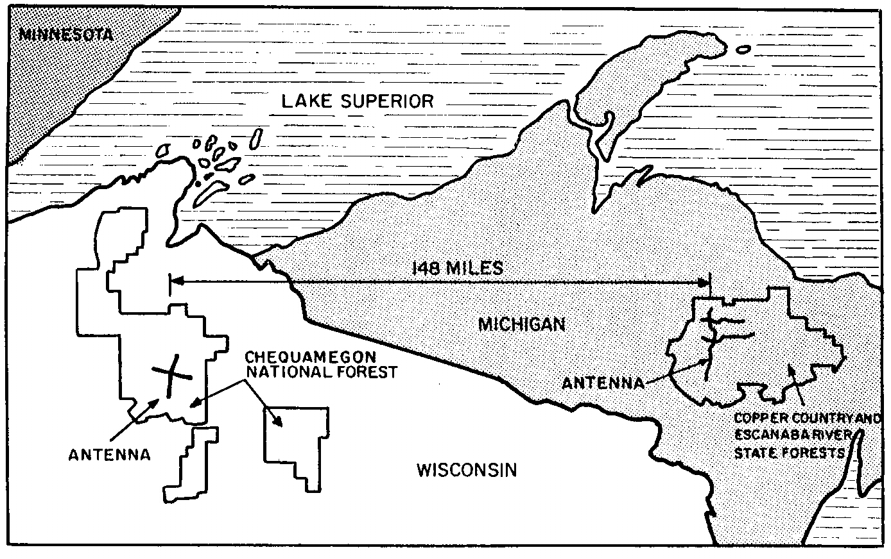

ELFS IN THE FOREST

Each facility consists of a transmitter, pole-mounted antenna cables, and buried ground terminals where the antenna currents enter the earth. The Navy Radio Transmitting Facility (NRTF) transmitters are located near the intersection of the antennas in each site. The NRTF at Clam Lake has two orthogonal antennas, one essentially oriented north-south (NS) and ther other east-west (EW), resembling a large “X.” Each antenna is 14 miles long and carry 300 amperes. The NRTF at Republic has one NS antenna (28 miles) and two parallel EW antennas (14 miles each), the whole system resembling an enormous “F”; overall current is 150 amperes. The transmitters have been operated either synchronously or independently to broadcast messages.

(From Technical Reports D06205-3 and D06214-6 by the IIT Research Institute, Chicago.)

According to Lowell L. Klessing and Victor L. Strite, “The reduction in land area and power required was made possible mainly because of a scientific breakthrough reported in November 1969. The nature of the breakthrough was never made clear. The discovery allowed smaller transmitters and 90% lower space requirements. Other technological advances then and later allowed for a compensating decrease in power: improved lightning neutralization, improved radio direction finder on submarines, increased knowledge about site conductivity, and improved antenna and receiver techniques. All of these improvements reduced the power requirements by a factor of 100, the Navy claimed.” ⁽²⁾

Not in My Backyard

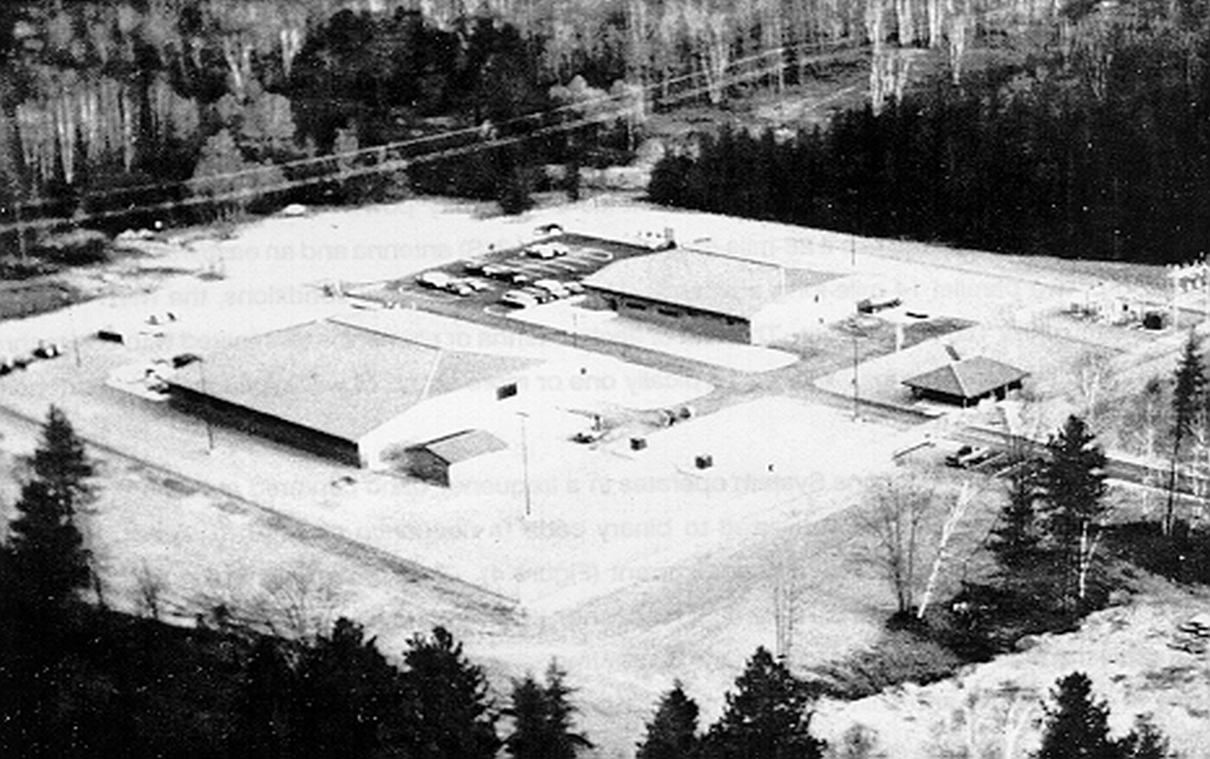
NRTF-Republic, Michigan

After the Clam Lake NRTF transmitter in Wisconsin was completed, construction of a second transmitter near Republic, Michigan, started in 1983. Intermittent operation began in March 1986 with low power testing, becoming a fully-operational Naval Communications Facility in October 1989. Since that time, it has operated at full power essentially 24 hours per day.

ELF transmitters have been the object of protests since their inception 30 years ago. In June 1998, US Senators Russ Feingold and Herb Kohl introduced an amendment to the Defense Authorization Bill which would terminate Project ELF. “Project ELF is an ineffective, unnecessary, and outdated Cold War relic that is not wanted by most residents in my state,” said Feingold. “We have almost succeeded in terminating the project twice before, and we are going to keep at it until we do. There is no doubt in my mind that the millions of defense dollars we spend on ELF can be put to better use supporting the National Guard.” Ten editorials have appeared in Wisconsin and Michigan newspapers calling for ELF to close.

In 1996, one protester, Tom Howard-Hastings went into “the world’s largest radio station,” as he misnamed the Michigan’s site (after all, it sends no “radio” waves as such) and cut down three of the antenna poles, shutting down the system for a couple of days.

Wisconsin and Michigan residents object to the ELF transmitters too, calling the project a nuisance. Metal fences in the surrounding area, for example, must be grounded to avoid severe shocks from the presence of high voltages. Several

THE GOLDEN FLEECE AWARD

More than 20 years ago, former Senator William Proxmire created the "Golden Fleece Award" to focus public attention on budgetary waste in government in the form of pork-barrel spending. He issued a Golden Fleece Award every month between March 1975 and December 1988. In his own words, the award singled out a "wasteful, ridiculous or ironic use of the taxpayers' money.”
The dubious distinction of a Golden Fleece Award was granted to federal programs that most Americans would agree were outrageous and wasteful. The Golden Fleece Awards did not necessarily have high costs, but rather violated a principle of responsible government spending.
For example, in December 1981, he bestowed a Golden Fleece award on the US Navy for keeping a bull at their Clam Lake Project ELF facility in Wisconsin as part of the Navy’s ELF health effects research program.
Over the years, almost every federal agency has received a Golden Fleece Award.

residents claim to hear the "Taos Hum,” a low, grumbling noise on the threshold of audibility. The hum is so named because it first received massive publicity in 1990 when it became "loud" in the New Mexico area around Taos. Soon many other people started reporting that they also could hear the “Taos Hum" worldwide.

On the other hand, faculty and researchers at the Michigan Technological University (MTU) School of Forestry and Wood Products have found that the Project ELF’s antenna grid makes the trees grow faster. MTU foresters have been studying the effects ever since the system became operational ten years ago. 

Note: Drawings from the book The ELF Odissey by L. Klessig and V. Strite.

(1) The project was in secret research and development in North Carolina and Virginia during 1958-67.
(2) The ELF Odyssey: National Security Versus Environmental Protection, Westview Press, 1980.

Return to The BDR Menu

